Lab 8 Customizations

Hands-on lab Step-by-Step

September 2021

# Lab Overview and Pre-requisites

This beginner-level lab gives you hands-on experience designing and developing a virtual agent, customer voice and adding images to sub grid in Model Driven Apps.

Here’s what you’ll learn:

* **Form Customization:** Adding command bar to show image from the Product sub grid in Opportunity form in Model Driven Apps.

# Exercise 1: Adding image viewer in Product form

Prerequisites:

* 2021 Release Wave 2 installed on instance.
* Demo data for Products imported (see Lab Assets)

## Task 1: Create New Model Driven App

1. Sign into Power Apps
2. On the left navigation pane, select Solutions and then open or create a solution to contain the new model-driven app.
3. Select New > App > Model-driven app
4. Select Modern app designer, and then select Create.

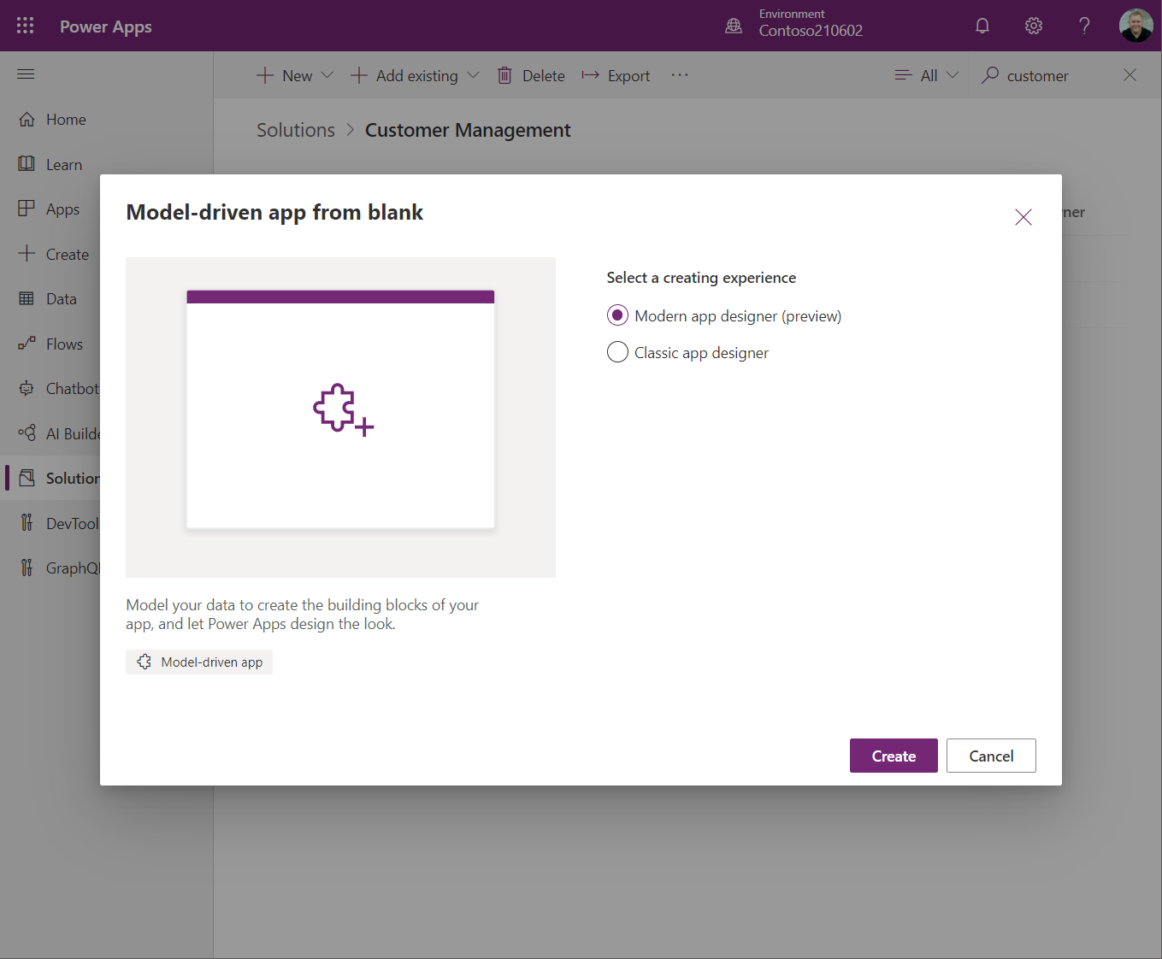

1. Enter Product Management as **Name** for your app, and then select **Create.**

## Task 2: Edit the command bar

1. Make sure you **Publish** your app before you work with the command designer.
2. **Add Page** within your model driven app and select **Table base view and form** and choose Product.

1. Open the command designer to edit a command bar

1. Select any table from the **Pages** area in the app designer.
2. Select **...** and then select **Edit command bar**.

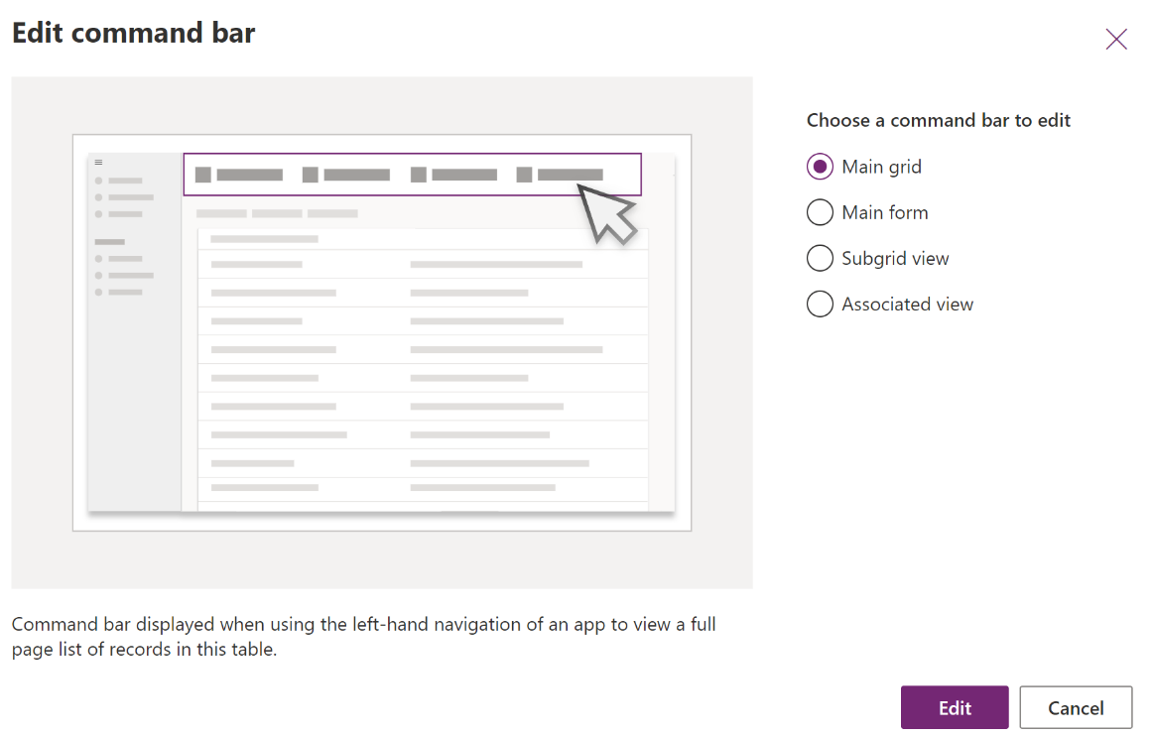

1. Select **Subgrid view**, and then select **Edit**.

## **Task 3: Create a new command**

1. [Open the command designer to edit a command bar](https://docs.microsoft.com/en-gb/powerapps/maker/model-driven-apps/use-command-designer#open-the-command-designer-to-edit-a-command-bar), and then select **+ New** on the command designer command bar.

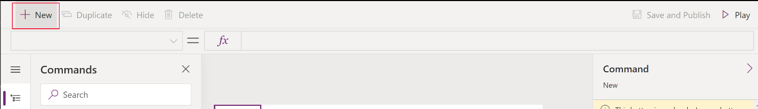

1. On the right pane, enter or select from the following options:

* **Label**. Enter “View Image” as label that will be displayed on the command button.
* **Icon**. Select an icon for the command button. You may choose from any system icons or web resource SVG files. For this, select **Use Icon**, and **View** as icon.
* **Tooltip title**. Enter “View product image“ as tooltip title. The title appears to the user when they hover their mouse over the command.
* **Tooltip description**. Enter “View product image from record url” as tooltip description. The description appears for the user below the tooltip title when they hover their mouse over the command.
* **Action**. Select **Run formula** and enter the Power Fx formula to run the command action

|  |
| --- |
| Launch(Self.Selected.Item.URL,{}, LaunchTarget.New) |

* **Visibility**. Select to **Always show**.
* Drag and drop the command to the desired location. You can arrange modern commands amongst classic commands.

* Select **Play** to run the command or **Save and Publish** to make the command available to app users.

## Task 4: Test the command button from Product form

* + 1. Open [Power Apps](https://make.powerapps.com/).
    2. Select Product Management app and Play

* + 1. Navigate to Product and change the view to All Product, Families & Bundles

* + 1. Search for Surface Hub and choose any product records uploaded from template.

* + 1. You will see View Image button is visible within the form.



* + 1. Click the button and it will open new tab displaying product image.

© 2021 Microsoft Corporation. All rights reserved.